1. Write a class called ***Room***.

***Room*** class has three public variables,

* length (double)
* breadth (double)
* height (double)

Also, it has two member functions that calculate the area and volume of the room.

In the main function,

* Assign the values of length, breadth, and height.
* Create an object from the class ***Room*** to calculate the area and volume of a room.
* Call the related member functions to perform the calculations.

Consider the sample run given below.

**Sample Run:**

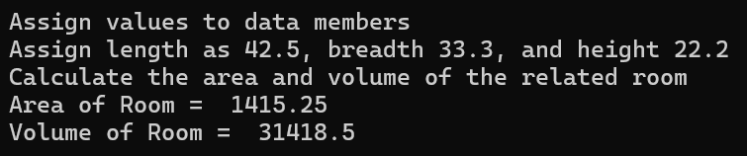

1. Increase the size of a 2x2 square with the user’s input. In your program, write a class named ***Square*** and an ***Increment*** class that has to be the ***friend class***. In your Increment class, you need a constructor to get the increment value from the user. Declare a *change()* function for increasing the size of the square and a print function for seeing a side of the square.

**Sample Run:**

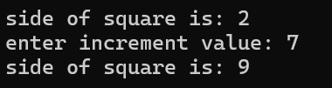

1. Write a class called Person. It has a string of private data members. Its data member is a read-only value. Its constructor takes one parameter and assigns its value to the data member. A copy constructor in the class copies the data members of a Person object to this class. In the copy, the constructor displays a message that says “Copy Cons” and copies the value by adding the “copy” string at the end.

Create a C++ display function that takes a Person object as a parameter. Inside the function display the data member of the Person object.

In the main function, create a Person object using your name. Then, call the display function using the Person object that was made.

**Sample Run:**

